**CHAPTER - I**

**1.INTRODUCTION**

Driver Drowsiness Detection (DDD) is a critical application aimed at enhancing road safety by identifying and mitigating the risks associated with driver fatigue. In this context, Python, OpenCV (Open Source Computer Vision), and the Shape Predictor 68 shape landmark detector play pivotal roles in developing an effective DDD system.

Python, a versatile and widely-used programming language, serves as the backbone for implementing the DDD system. Its extensive libraries and frameworks make it an ideal choice for handling image processing tasks and real-time data analysis. OpenCV, a powerful computer vision library, complements Python by providing a suite of tools and algorithms for image and video processing, making it integral for detecting facial landmarks and expressions indicative of drowsiness.

The Shape Predictor 68 shape landmark detector is a specific model within the dlib library, designed to identify 68 key facial landmarks. These landmarks include features such as eyes, nose, and mouth, which are crucial for assessing driver alertness. By analyzing the variations in these facial landmarks over time, the system can recognize patterns associated with drowsiness, allowing for timely intervention to prevent potential accidents.

The DDD system operates by continuously capturing and processing images or video frames of the driver's face in real-time. OpenCV facilitates tasks such as face detection and landmark localization, while the Shape Predictor enhances precision by identifying specific points on the face. Through Python's programming capabilities, these landmarks can be monitored and analyzed, enabling the system to detect subtle signs of drowsiness, such as drooping eyelids or changes in facial expressions.

In summary, the synergy between Python, OpenCV, and the Shape Predictor 68 shape landmark detector empowers the development of an advanced Driver Drowsiness Detection system. This technology holds immense potential for enhancing road safety by providing a proactive approach to address the risks associated with driver fatigue, ultimately contributing to the overall well-being of motorists and pedestrians alike.

**1.1 SYSTEM SPECIFICATION**

**1.1.1 HARDWARE CONFIGURATION:**

SYSTEM : Minimum Intel i3 or Ryzen 3 3rd gen

STORAGE : 15GB Space Minimum

WEB CAM : 2 MP Standard Camera

RAM : 8 GB Minimum

MONITOR : 16” Inch Minimum

SPEAKER : Any <12V Speaker or Buzzer

**1.1.2 SOFTWARE SPECIFICATION:**

OPERATING SYSTEM : Windows 10 or above

FRONT END : Python

TOOL : Python IDLE (3.10.9) or VS Code

**CHAPTER - II**

**2. SYSTEM STUDY**

**2.1 EXISTING SYSTEM**

**2.1.1 DESCRIPTION**

The Existing concern relied on various technologies such as eye tracking systems, steering behaviour analysis, and physiological sensors. Eye tracking systems monitored blink rates and eye closure duration to gauge alertness, while steering behaviour analysis observed erratic driving patterns indicative of drowsiness. EEG technology measured brainwave activity, offering insights into cognitive states, but faced challenges due to its bulkiness. Physiological sensors, embedded in seats or worn as wearables, monitored indicators like heart rate for signs of fatigue. Vibration alerts in steering wheels or seats aimed to wake up drowsy drivers. Some systems fused data from multiple sensors for enhanced accuracy.

Although these early technologies laid the foundation, the advent of OpenCV and the 68 landmarks model marked a substantial advancement, offering real-time, adaptable, and robust solutions for driver drowsiness detection, significantly improving the effectiveness and applicability of such safety systems.

**2.1.2 DRAWBACKS OF EXISTING SYSTEM:**

Before the widespread use of OpenCV and the 68 landmarks model, various technologies and approaches existed for driver drowsiness detection. Some of the earlier methods include:

**1. Eye Tracking Systems:**

Traditional eye-tracking systems focused on monitoring eye movement patterns to detect signs of drowsiness. These systems used specialized cameras to track the driver's eye movements, particularly changes in blink rate and eye closure duration. While effective to some extent, they often required sophisticated hardware and were sensitive to environmental conditions.

**2. Steering Behavior Analysis:**

Certain systems analyzed the driver's steering behavior as an indicator of drowsiness. Algorithms were designed to detect erratic steering patterns, such as drifting between lanes or sudden corrections, which could suggest a lack of alertness.

**3. Electroencephalography (EEG) Technology:**

EEG-based systems measured brainwave activity to assess the driver's cognitive state. As drowsiness is associated with specific EEG patterns, these systems could provide insights into the driver's mental fatigue. However, EEG systems were often bulky and intrusive, limiting their practicality for in-vehicle use.

**4. Physiological Sensors:**

Wearable devices or sensors embedded in the vehicle seat could monitor physiological signals like heart rate or skin conductance. Changes in these signals were interpreted as indicators of drowsiness. While potentially accurate, these systems faced challenges related to user comfort and acceptance.

**5. Vibration Alerts:**

Some systems relied on haptic feedback to alert drowsy drivers. Vibrations in the steering wheel or seat were triggered when signs of drowsiness were detected. This approach aimed to wake up the driver without relying on visual or auditory cues.

**6. Combined Sensor Fusion:**

More advanced systems integrated multiple sensors, combining data from cameras, steering behavior, physiological signals, and other sources. This sensor fusion approach sought to enhance the accuracy and robustness of drowsiness detection.

While these earlier technologies laid the groundwork for driver drowsiness detection, the advent of computer vision and machine learning, as exemplified by OpenCV and the 68 landmarks model, marked a significant leap forward. These newer approaches benefit from improved accuracy, real-time processing capabilities, and the ability to adapt to diverse facial expressions and conditions, making them increasingly popular in modern driver assistance systems.

**2.2 PROPOSED SYSTEM:**

**2.2.1 DESCRIPTION**

The proposed driver drowsiness detection system integrates various Python libraries, leveraging their specific functionalities for an effective solution. OpenCV is utilized for real time video processing, while Dlib, with its 68 landmarks model, provides precise facial feature detection. NumPy enhances numerical operations and data manipulation, facilitating efficient data processing.

The face_recognition library is employed for facial recognition tasks, allowing the system to identify and track the driver's face for continuous monitoring. Winsound, a Windows-specific library, is used to generate audio alerts in response to detected signs of drowsiness, ensuring immediate driver attention.

Python serves as the overarching programming language, orchestrating the integration of these libraries into a cohesive system. The combination of these tools enables the system to analyze facial landmarks, track eye movements, and assess overall facial expressions. When drowsiness is detected, the system triggers Winsound to issue an alert, prompting the driver to regain focus. This proposed system harnesses the strengths of these libraries to create a robust and efficient driver safety solution.

**2.2.2 FEATURES:**

The proposed driver drowsiness detection system, leveraging OpenCV, Dlib, NumPy, face_recognition, Winsound, and Python, presents several advantages:

**1. Real-time Processing:**

The integration of OpenCV and Dlib enables real-time video processing, ensuring timely detection of facial landmarks and expressions associated with drowsiness.

**2. Accurate Facial Feature Detection:**

Dlib's 68 landmarks model provides accurate detection of facial features, allowing the system to precisely monitor eye movements, blink patterns, and other indicators of drowsiness.

**3. Facial Recognition Capability:**

The inclusion of the face_recognition library enhances the system's ability to recognize and track the driver's face consistently, even in varying conditions.

**4. Efficient Numerical Operations:**

NumPy facilitates efficient numerical operations and data manipulation, optimizing the processing of facial landmark data and enhancing the overall performance of the system.

**5. Platform Compatibility:**

Winsound's integration ensures platform compatibility, allowing the system to generate audio alerts on Windows systems, enhancing the user experience.

**6. Versatility:**

The use of Python as the programming language makes the system versatile and accessible, facilitating easy integration with other libraries and potential future expansions or modifications.

**7. Non-Intrusive Alert Mechanism:**

Winsound's capability to generate audio alerts provides a non-intrusive means of notifying the driver, allowing for a quick and effective response to signs of drowsiness without relying solely on visual cues.

**8. Open Source Nature:**

Many of these libraries, including OpenCV, Dlib, and NumPy, are open-source, promoting collaboration, transparency, and community-driven improvements.

**9. Potential for Integration**:

The modular nature of the proposed system allows for potential integration with additional sensors or technologies, enhancing its capabilities or adapting to specific user requirements.

**10. User-friendly Implementation:**

Python's readability and simplicity contribute to the user-friendly nature of the system, making it accessible to developers and potentially facilitating widespread adoption in various applications.

**CHAPTER - III**

**3. SYSTEM DESIGN AND DEVELOPMENT**

**3.1 FILE DESIGN:**

The file design for the Driver Drowsiness Detection System is structured for modularity and clarity. The main script, `main.py`, orchestrates the system's functionality. Modules include `image_processing` for video frame handling, `landmark_detection` for facial landmark identification using Dlib, and `face_recognition` for consistent driver face tracking. `numerical_operations` leverages NumPy for efficient data manipulation. The drowsiness detection algorithm resides in `drowsiness_detection`. Winsound is integrated into `audio_alert` for generating audio warnings. A configuration file, `config.py`, stores adjustable parameters. Utilities are managed in `utilities.py`, and optional data logging is handled by `data_logging.py`. Comprehensive documentation is provided in `README.md`, and version control is facilitated through `. git` and `gitignore`. This organized structure enhances code readability, facilitates collaboration, and allows for seamless system expansion or modification.

* How seamlessly does the system integrate Python, OpenCV, Dlib, NumPy, face_recognition, and Winsound, ensuring compatibility and smooth interoperability?
* What data should be given as input?
* How the data should be arranged or coded?
* The Dialog to guided the operating personnel in providing input
* Methods for preparing input validations and steps to follow when error occur.

**3.2 INPUT DESIGN**

The input design ensures flexibility, adaptability, and user engagement by incorporating various sources of information, configurations, and potential external triggers for the Driver Drowsiness Detection System.

**Input Design for Driver Drowsiness Detection System:**

**1. Video Feed Input:**

The primary input is the video feed captured by an in-vehicle camera, providing real-time visual data of the driver's face and expressions.

**2. Camera Specifications:**

Configurable settings in `config.py` to specify camera parameters such as resolution, frame rate, and camera placement for adapting to different hardware configurations.

**3. Configuration File:**

User-configurable settings within `config.py` to adjust thresholds, sensitivity levels, and other parameters related to facial landmark detection and drowsiness assessment.

**4. Test Datasets (Optional):**

If applicable, the system may include an option to use test datasets for validation and performance evaluation during system development and testing phases.

**5. Initialization Parameters:**

Parameters specified in the `initialize.py` script for setting up the system, including dependencies, environment variables, and any initial configurations.

**6. User Interaction (Optional):**

If a user interface module (`user_interface.py`) is implemented, user interactions such as manual alert triggering or system toggling may serve as additional inputs for user engagement.

**7. External Triggers (Optional):**

Provision for external triggers, like integration with vehicle sensors or IoT devices, to enhance the system's adaptability and responsiveness to varying driving conditions.

**8. Pre-processing Options:**

Configuration options for pre-processing steps in `image_processing.py`, allowing users to apply filters, adjustments, or enhancements to optimize facial feature extraction.

**9. Data Logging (Optional):**

Parameters or flags in `data_logging.py` to enable or disable data logging, specifying the format and location of log files for post-analysis and system improvement.

**3.3 OUTPUT DESIGN**

The output design for the Driver Drowsiness Detection System is meticulously crafted to provide a comprehensive and intuitive user experience. Visual feedback is a cornerstone, with Dlib's 68 facial landmarks dynamically displayed on the driver's face, offering a real-time visual representation of key features. Drowsiness indicators, manifested through color changes or overlays, serve as immediate alerts, and intuitive symbols convey the system's assessment of the driver's alertness levels. This graphical approach enhances transparency, allowing users to understand the system's analysis at a glance.

Auditory feedback, facilitated by the Winsound library, introduces an additional layer of alertness with customizable alert sounds. The intensity of these auditory alerts can be configured through the `config.py` file, accommodating user preferences. A potential extension to the system includes haptic feedback, such as seat vibrations, offering a tactile dimension to alert mechanisms. Real-time frame annotations on the video feed provide dynamic information, offering insights into blink rates and other relevant metrics.

For a more detailed analysis, graphical trends, available in a separate window, showcase historical drowsiness levels over time. Textual feedback in the console or a dedicated interface complements visual and auditory outputs, providing detailed information about detected facial expressions and system metrics. Logging and reporting features capture drowsiness events, alert timestamps, and performance metrics for post-analysis, system improvement, and compliance reporting.

The user interface, if implemented, acts as a centralized dashboard where users can monitor real-time outputs, view historical data, and customize settings. The system's status is indicated through colored icons or LEDs, providing at-a-glance information about its overall functionality. Acknowledgment mechanisms allow users to confirm alerts, promoting a collaborative approach to driver attention management. Notifications for customization changes ensure users are informed about any modifications to configurations. This output design prioritizes clarity, adaptability, and user engagement, contributing to the overall effectiveness of the Driver Drowsiness Detection System.

**1. Visual Output:**

The primary visual output is a graphical representation overlaying the video feed, indicating detected facial landmarks, regions of interest, and real-time analysis results.

**2. Facial Landmark Visualization:**

Dlib's 68 landmarks are visualized on the driver's face, allowing for a real-time display of key facial features such as eyes, nose, and mouth, aiding in system transparency.

**3. Drowsiness Indicators:**

Visual cues, such as color changes or overlays, dynamically convey the system's assessment of drowsiness levels based on detected facial expressions and patterns.

**4. Alert Symbols:**

Intuitive symbols or icons appear when drowsiness is detected, providing an immediate visual alert to the driver about the need for attention.

**5. Graphical Trends (Optional):**

Graphs or plots depicting historical drowsiness levels over time, available in a separate window or interface, offer a retrospective analysis for both the driver and system evaluators.

**6. Real-time Frame Annotations:**

Each video frame can be annotated with relevant information, including timestamped alerts, blink rates, and other dynamic indicators, enhancing the interpretability of the output.

**7. Auditory Output:**

Winsound library generates audible alerts, such as beeps or alarms, when the system detects sustained signs of drowsiness, providing an additional layer of attention redirection.

**8. Alert Sound Intensity (Configurable):**

Users can configure the intensity or volume of the alert sound through parameters in the `config.py` file, ensuring it aligns with user preferences and doesn't cause discomfort.

**9. Haptic Feedback (Potential Extension):**

For further user engagement, the system might incorporate haptic feedback, such as seat vibrations, triggered during severe drowsiness instances, ensuring a multi-sensory alert mechanism.

**10. Textual Feedback (Console or Interface):**

Text-based feedback in the console or a dedicated interface provides detailed information, including detected facial expressions, blink rates, and any additional relevant metrics.

**11. Logging and Reporting:**

Logged data, including drowsiness events, alert timestamps, and system performance metrics, is stored in log files for post-analysis, system improvement, and compliance reporting.

**12. User Interface (Optional):**

If a user interface (`user_interface.py`) is implemented, it provides a centralized dashboard where users can monitor system outputs, view historical data, and customize settings.

**13. System Status Indicator:**

A system status indicator, such as a colored icon or LED, provides at-a-glance information about the overall health and functionality of the drowsiness detection system.

**14. User Acknowledgment Mechanism:**

The system allows users to acknowledge alerts, potentially through voice commands or manual triggers, ensuring a collaborative approach to driver attention management.

**15. Customization Notifications:**

Whenever users adjust configurations or thresholds, the system may provide notifications to confirm the changes and ensure users are aware of any modifications made.

The comprehensive output design ensures that the Driver Drowsiness Detection System delivers effective, user-friendly, and multi-modal feedback to the driver while offering valuable insights for system evaluation and improvement.

**3.4 CODE DESIGN**

This code design involves making decisions about how the software will be structured, organized, and implemented to meet its specified requirements. Code design is a crucial phase in the software development life cycle as it directly influences the quality, maintainability, and scalability of the resulting code.

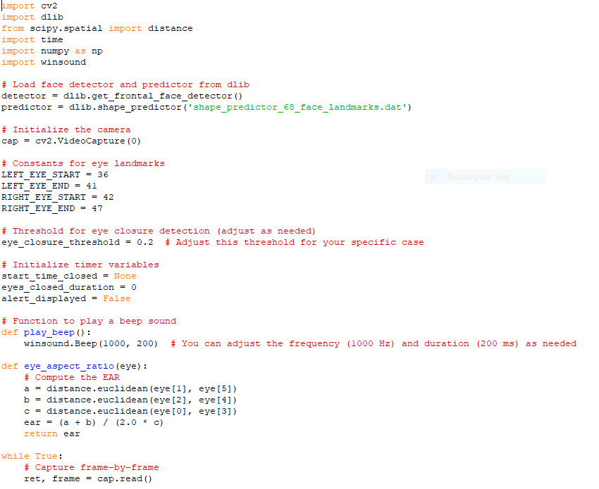

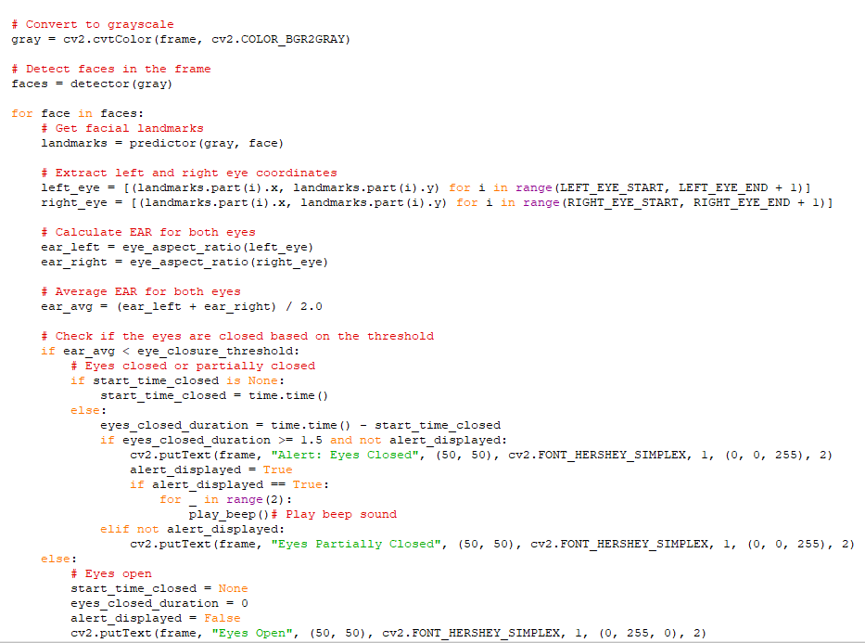

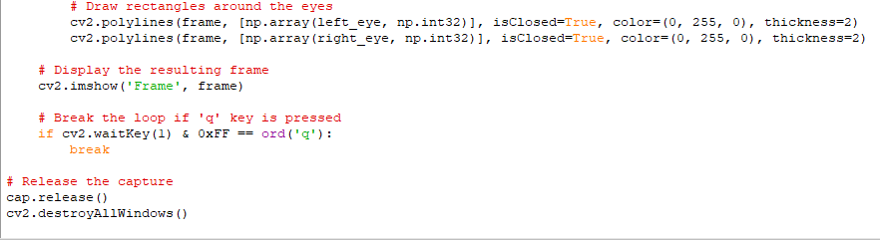

**Key aspects of code design include:**

**1. Modularity:**

Breaking down the software into smaller, manageable components or modules. Each module has a specific and well-defined responsibility, making the code easier to understand, maintain, and update.

**2. Abstraction**:

Creating abstract representations of complex systems to simplify understanding and focus on essential features. Abstraction hides unnecessary details and emphasizes what is essential for a particular task.

**3. Encapsulation:**

Bundling data and methods that operate on the data into a single unit, known as a class or module. Encapsulation restricts access to certain parts of the code, promoting information hiding and reducing dependencies.

**4. Reusability:**

Designing code in a way that allows components or modules to be reused in different parts of the software or even in other projects. Reusable code reduces redundancy and development time.

**5. Scalability:**

Designing code to handle potential growth in data, users, or features without sacrificing performance. Scalable code adapts well to changes in requirements or increased workloads.

**6. Flexibility and Extensibility:**

Creating code that can be easily modified or extended to accommodate changes in requirements or the addition of new features. Flexibility ensures that the software can evolve over time.

**7. Readability and Maintainability:**

Structuring code in a way that makes it easy to read and understand. Clear and well-documented code facilitates maintenance, debugging, and collaboration among team members.

**8. Performance Optimization:**

Considering performance implications during the design phase and making design choices that prioritize efficiency without compromising other design principles.

**9. Testing and Debugging:**

Designing code with testing in mind, including creating modular components that are easy to test individually. Debugging-friendly code simplifies the identification and resolution of issues.

**10. Security:**

Incorporating secure coding practices into the design to mitigate potential vulnerabilities and ensure that the software is resistant to various security threats.

Code design aims to create a structure that not only meets functional requirements but also aligns with principles that contribute to the creation of robust, maintainable, and adaptable software systems.

**3.5 SYSTEM DEVELOPMENT**

**3.5.1 DESCRIPTION OF MODULES**

**MODULES:**

**1. Main Module :**

The main module serves as the control center, orchestrating the flow of execution and coordinating the interaction between various modules. It initializes the system, captures video frames, and delegates tasks to other components for seamless integration.

**2. Video Processing Module :**

Responsible for handling video frames using the OpenCV library, this module encapsulates the logic for capturing and pre-processing images. It optimizes facial feature extraction by applying filters or adjustments, ensuring the input data is well-prepared for subsequent analysis.

**3**. **Facial Landmark Detection Module :**

landmarks model, this module precisely identifies facial features. It contains functions specific to facial landmark detection, facilitating accurate tracking of key points on the driver's face. The separation of this functionality enhances code readability and allows for focused development and testing.

**4. Driver Face Recognition Module :**

This module manages facial recognition tasks, ensuring continuous tracking of the driver's face. By integrating with the landmark detection module, it enhances the overall accuracy of facial feature identification. The modular design facilitates easy updates or improvements in facial recognition algorithms.

**5. Drowsiness Detection Module :**

At the core of the system, this module implements the algorithm for assessing drowsiness. Analyzing facial expressions, blink rates, and other indicators, it determines the driver's alertness level. Its modular structure allows for easy adjustments or replacements of the drowsiness detection logic.

**­­6. Audio Alert Module :**

Integrating Winsound, this module is responsible for generating audio alerts when signs of drowsiness are detected. With configurable parameters for alert intensity and duration, it provides flexibility in tailoring the alert mechanism to suit user preferences.

**7. Configuration Module :**

Centralizing configurable parameters in a dedicated module simplifies system customization. Developers can easily adjust camera settings, thresholds, or alert configurations without modifying the core code, promoting adaptability and flexibility.

**8. User Interface Module :**

If implemented, the user interface module manages interactions with the user, offering a visual representation of system outputs and customization options. It enhances user experience, making the system more accessible and user-friendly.

**9. Initialization Module :**

The initialization script ensures a consistent starting point for the system. It handles the setup of dependencies and configurations, reducing the risk of errors during system startup and providing a clean, organized entry point for execution.

**10. Utilities Module :**

The utilities module serves as a repository for generic functions, promoting code modularization. It includes commonly used functions for file handling, logging, or any other tasks that enhance the overall readability and maintainability of the codebase.

**11. Data Logging Module :**

For system analysis and improvement, the data logging module captures relevant data during operation. Configurable options for log formats and locations allow developers to tailor logging to specific needs, aiding in post-analysis and troubleshooting.

**12. Testing Module :**

The tests directory contains unit tests for validating the functionality of individual modules. It ensures the reliability and correctness of the system, facilitating ongoing development, and helping prevent regressions during updates.

These modules contribute to a well-organized and modular structure, enhancing code readability, maintainability, and scalability. Each module focuses on a specific aspect of the system, promoting a clear separation of concerns and facilitating easier development and testing.

**CHAPTER - IV**

**4. TESTING AND IMPLEMENTATION**

**SYSTEM TESTING**

This comprehensive testing evaluates the entire application, ensuring that all components work harmoniously and meet specified requirements. It includes various testing types, such as functional, performance, and security testing, to validate the system's reliability under real-world conditions.

System testing aims to uncover defects, inconsistencies, and potential vulnerabilities, providing a holistic view of the software's readiness for deployment. It verifies that the application functions as intended, meets user expectations, and adheres to quality standards, paving the way for a robust and reliable software release.

**TYPES OF TESTING**

**1. Unit Testing:**

- Unit testing involves evaluating individual components in isolation. By testing each module independently, developers can identify and address any issues within specific functionalities, ensuring the reliability of each part of the system.

**2. Integration Testing:**

- Integration testing verifies that different modules work cohesively together. It ensures that data flows seamlessly between components and that the integrated system behaves as expected. This type of testing is crucial for detecting issues that may arise during interactions between modules.

**3. End-to-End Testing:**

- End-to-end testing assesses the system as a whole, simulating real-world scenarios from video processing to drowsiness detection and alert generation. It provides a comprehensive evaluation of the entire workflow, ensuring that all components collaborate effectively.

**4. User Interface Testing:**

- UI testing focuses on the responsiveness and user-friendliness of the interface. It evaluates how well the user interface communicates system status and alerts, ensuring a positive user experience.

**5. Regression Testing:**

- Regression testing validates that new code changes do not negatively impact existing functionalities. It involves retesting previously working features after updates, preventing unintended consequences and maintaining system stability.

**6. Performance Testing:**

- Performance testing assesses how well the system handles different conditions, such as varying video qualities or processing loads. It ensures that the system meets performance requirements and identifies areas for improvement.

**7. Security Testing:**

- Security testing examines the system for vulnerabilities, ensuring that sensitive data is handled securely and that the system is resilient against common security threats. It is crucial for protecting the integrity and confidentiality of the application.

**8. Usability Testing:**

- Usability testing evaluates the user interface's effectiveness, efficiency, and satisfaction. It provides valuable feedback on how easily users can interact with the system, enhancing the overall user experience.

**9. Scalability Testing:**

- Scalability testing assesses the system's ability to handle increased workloads or users. It is essential for ensuring that the application can scale smoothly without compromising performance or responsiveness.

**10. Error Handling and Edge Case Testing:**

- This type of testing examines how well the system responds to unexpected inputs or scenarios. It ensures that error messages are clear, and the system gracefully handles edge cases without crashing or providing confusing outputs.

**IMPLEMENTATION:**

**1. Coding Standards:**

Adhering to coding standards ensures consistency and readability in the codebase. Descriptive variable and function names contribute to the code's clarity and maintainability.

**2. Modular Development:**

Implementing modules independently with a focus on separation of concerns makes the codebase more manageable. It simplifies testing, debugging, and future modifications by isolating functionalities.

**3. Version Control:**

Utilizing version control systems like Git allows developers to track changes, collaborate effectively, and roll back to previous versions if needed. It facilitates collaboration and ensures code integrity.

**4. Documentation:**

Comprehensive documentation, including inline comments and README files, enhances code understanding and future maintenance. Well-documented code is essential for collaboration and knowledge transfer.

**5. Error Handling:**

Robust error handling mechanisms ensure that the system can manage unexpected situations gracefully. Providing clear error messages aids in debugging and helps users or developers understand issues.

**6. Scalability Considerations:**

Designing code with scalability in mind allows the application to accommodate future growth. Considering potential enhancements during implementation ensures that the codebase remains adaptable.

**7. Testing Integration:**

Integrating testing into the development process, especially through automated testing, streamlines the testing phase. Automated tests catch issues early in the development cycle, improving code quality.

**8. Security Measures:**

Implementing security measures based on best practices, such as input validation and data encryption, helps protect against potential threats. Following secure coding guidelines is crucial for safeguarding sensitive information.

**9. Performance Optimization:**

Optimizing code for performance involves identifying and addressing bottlenecks. Techniques such as asynchronous processing or parallelization can enhance the system's speed and responsiveness.

**10. User Interface Responsiveness:**

Ensuring a responsive user interface involves implementing features like loading indicators and asynchronous updates. A responsive UI contributes to a positive user experience, enhancing usability.

**5. CONCLUSION**

In this projects computer vision, facial landmark detection, and drowsiness assessment algorithms, the system demonstrates a potential to mitigate the risks associated with driver fatigue.

Throughout the development process, key considerations such as modular code design, systematic testing, and thoughtful implementation have contributed to the creation of a robust and efficient system. The utilization of technologies like OpenCV, Dlib, NumPy, and Winsound, combined with Python programming, showcases the versatility and effectiveness of these tools in real-world applications.

The project's success lies not only in its technical achievements but also in its potential impact on road safety. The implementation of features like real-time drowsiness detection, audio alerts, and configurable settings highlights the adaptability and user-centric approach of the system.

However, it's essential to recognize that the project's scope and effectiveness may vary based on factors such as hardware capabilities, environmental conditions, and user compliance. Additionally, ongoing improvements, updates, and considerations for user feedback will play a crucial role in refining the system and ensuring its continuous relevance.

In conclusion, the Driver Drowsiness Detection System represents a commendable effort in applying cutting-edge technologies to address a critical safety concern. As with any technology, collaboration, user education, and future enhancements will be vital for maximizing its positive impact on road safety and fostering a safer driving environment.

**6.FUTURE ENHANCEMENT**

Implement real-time eye gaze tracking for more accurate detection.Integrate machine learning algorithms to adaptively adjust sensitivity based on individual driving patterns.Utilize facial recognition to differentiate between the driver and passengers for improved accuracy.Incorporate voice recognition to detect signs of drowsiness through speech patterns.Integrate sensors to monitor physiological signals like heart rate and skin conductance.Develop a mobile application for remote monitoring and alerts. Implement a feature to detect distractions such as mobile phone usage. Integrate GPS data to detect changes in driving behavior or deviation from regular routes.Develop a dashboard for visualizing drowsiness trends over time. Add a feature to automatically adjust vehicle settings (e.g., seat position, cabin temperature) to help combat drowsiness.Implement an emergency notification system to alert designated contacts in critical situations.Integrate with smart wearable devices for continuous monitoring.Develop a mechanism to provide real-time feedback to the driver, such as alarms or seat vibrations.Implement a fatigue scoring system to quantify the level of drowsiness.Incorporate a database for storing historical data and generating insights.Develop a mechanism for collaborative drowsiness detection in shared vehicle environments.Integrate with existing driver assistance systems for seamless operation.Implement adaptive lighting systems within the vehicle to mitigate drowsiness effects.Develop a mechanism for self-calibration to account for varying environmental conditions.Explore the use of deep learning techniques for more advanced drowsiness detection algorithms.

**7. BIBLIOGRAPHY**

**REFERENCES**

[1] A.S. Bhat et al., Real-time Driver Drowsiness Detection using Facial Landmark Points and Machine Learning, 2020 - Explores a DDD system using Python, OpenCV, and facial landmarks for drowsiness classification.

[2] S. Islam et al., Drowsiness Detection using Facial Feature Extraction and Machine Learning Techniques, 2019 - Employs Python, OpenCV, and facial landmarks for DDD, focusing on eye features for drowsiness assessment.

[3] A. Singh et al., A Driver Drowsiness Detection System using Facial Landmarks and Machine Learning, 2021 - Presents a DDD system using Python, OpenCV, and facial landmarks, utilizing SVM for classification.

[4] S. Roy et al., Driver Drowsiness Detection using Eyelid Features and Machine Learning, 2020 - Implements a DDD system with Python, OpenCV, and facial landmarks, analyzing eye features for drowsiness detection.

[5] M. Aly et al., Real-Time Driver Drowsiness Detection System using Facial Landmarks, 2018 - Leverages Python, OpenCV, and facial landmarks for real-time DDD, employing eye features for drowsiness detection.

[6] Adrian Bulat and George Tzimiras, A Detailed Investigation of Deep Convolutional Neural Network Architectures for Facial Landmark Localization, 2016 - Explores deep learning architectures for facial landmark detection, relevant to the Shape Predictor model.

[7] Davis King, Dlib-ml: A Machine Learning Toolkit Built on Top of Dlib, 2017 - Introduces dlib-ml, including the Shape Predictor model for facial landmark detection.

[8] M. Jothi et al., A Survey of Techniques Used in Computer Vision for Driver Drowsiness Detection, 2019 - Provides an overview of DDD techniques, including facial landmark analysis.

[9] A. Hassan et al., A Review of Driver Drowsiness Detection Techniques, 2017 - Discusses various approaches for DDD, including vision-based methods and machine learning techniques.

[10] S. Raschka, A Gentle Introduction to Support Vector Machines, 2021 - Offers a beginner-friendly introduction to Support Vector Machines (SVM), potentially used in DDD systems

[11] Aurelien Geron, Hands-On Machine Learning with Scikit-Learn, Keras & TensorFlow, 2019 - Provides a practical guide to machine learning, potentially relevant for drowsiness classification.

**APPENDICES**

1. **DATA FLOW DIAGRAM**

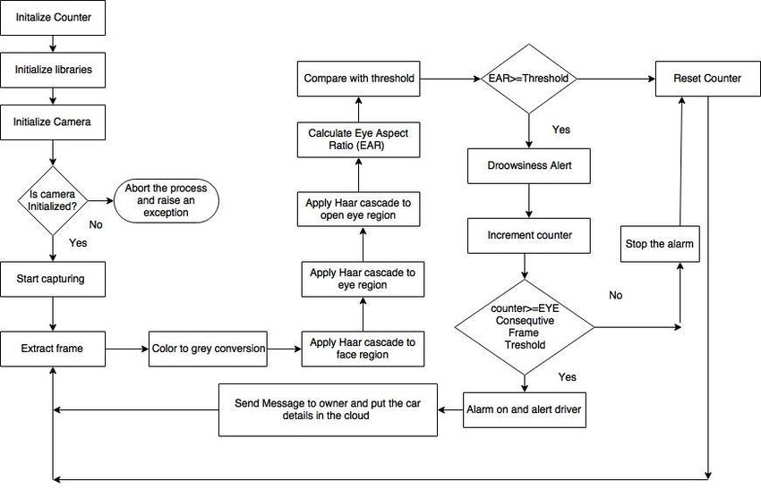

1. **TABLE STRUCTURE**

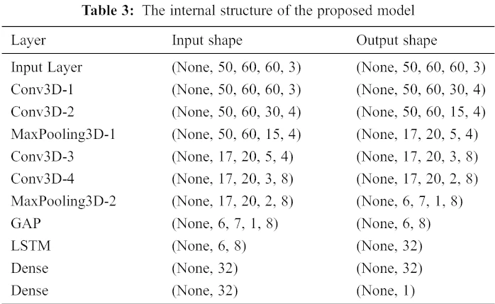

1. **SAMPLE CODING**

import cv2

import dlib

from scipy.spatial import distance

import time

import numpy as np

import winsound

# Load face detector and predictor from dlib

detector = dlib.get_frontal_face_detector()

predictor = dlib.shape_predictor

('shape_predictor_68_face_landmarks.dat')

# Initialize the camera

cap = cv2.VideoCapture(0)

# Constants for eye landmarks

LEFT_EYE_START = 36

LEFT_EYE_END = 41

RIGHT_EYE_START = 42

RIGHT_EYE_END = 47

# Threshold for eye closure detection (adjust as needed)

eye_closure_threshold = 0.2 # Adjust this threshold for your specific case

# Initialize timer variables

start_time_closed = None

eyes_closed_duration = 0

alert_displayed = False

# Function to play a beep sound

def play_beep():

winsound.Beep(1000, 200) # You can adjust the frequency (1000 Hz) and duration (200 ms) as needed

def eye_aspect_ratio(eye):

# Compute the EAR

a = distance.euclidean

(eye[1], eye[5])

b = distance.euclidean

(eye[2], eye[4])

c = distance.euclidean

(eye[0], eye[3])

ear = (a + b) / (2.0 * c)

return ear

while True:

# Capture frame-by-frame

ret, frame = cap.read()

# Convert to grayscale

gray = cv2.cvtColor

(frame, cv2.COLOR_BGR2GRAY)

# Detect faces in the frame

faces = detector(gray)

for face in faces:

# Get facial landmarks

landmarks = predictor(gray, face)

# Extract left and right eye coordinates

left_eye = [(landmarks.part(i).x,

landmarks.part(i).y)

for i in range(LEFT_EYE_START, LEFT_EYE_END + 1)]

right_eye = [(landmarks.part(i).x, landmarks.part(i).y) for i in range

(RIGHT_EYE_START, RIGHT_EYE_END + 1)]

# Constants for eye landmarks

LEFT_EYE_START = 36

LEFT_EYE_END = 41

RIGHT_EYE_START = 42

RIGHT_EYE_END = 47

# Threshold for eye closure detection (adjust as needed)

eye_closure_threshold = 0.2 # Adjust this threshold for your specific case

# Initialize timer variables

start_time_closed = None

eyes_closed_duration = 0

alert_displayed = False

# Function to play a beep sound

def play_beep():

winsound.Beep(1000, 200) # You can adjust the frequency (1000 Hz) and duration (200 ms) as needed

def eye_aspect_ratio(eye):

# Compute the EAR

a = distance.euclidean

(eye[1], eye[5])

b = distance.euclidean

(eye[2], eye[4])

c = distance.euclidean

(eye[0], eye[3])

ear = (a + b) / (2.0 * c)

return ear

while True:

# Capture frame-by-frame

ret, frame = cap.read()

# Convert to grayscale

gray = cv2.cvtColor

(frame, cv2.COLOR_BGR2GRAY)

# Detect faces in the frame

faces = detector(gray)

for face in faces:

# Get facial landmarks

landmarks = predictor(gray, face)

# Extract left and right eye coordinates

left_eye = [(landmarks.part(i).x,

landmarks.part(i).y)

for i in range(LEFT_EYE_START, LEFT_EYE_END + 1)]

right_eye = [(landmarks.part(i).x, landmarks.part(i).y) for i in range

(RIGHT_EYE_START, RIGHT_EYE_END + 1)]

# Constants for eye landmarks

LEFT_EYE_START = 36

LEFT_EYE_END = 41

RIGHT_EYE_START = 42

RIGHT_EYE_END = 47

# Threshold for eye closure detection (adjust as needed)

eye_closure_threshold = 0.2 # Adjust this threshold for your specific case

# Initialize timer variables

start_time_closed = None

eyes_closed_duration = 0

alert_displayed = False

# Function to play a beep sound

def play_beep():

winsound.Beep(1000, 200) # You can adjust the frequency (1000 Hz) and duration (200 ms) as needed

def eye_aspect_ratio(eye):

# Compute the EAR

a = distance.euclidean

(eye[1], eye[5])

b = distance.euclidean

(eye[2], eye[4])

c = distance.euclidean

(eye[0], eye[3])

ear = (a + b) / (2.0 * c)

return ear

while True:

# Capture frame-by-frame

ret, frame = cap.read()

# Convert to grayscale

gray = cv2.cvtColor

(frame, cv2.COLOR_BGR2GRAY)

# Detect faces in the frame

faces = detector(gray)

for face in faces:

# Get facial landmarks

landmarks = predictor(gray, face)

# Extract left and right eye coordinates

left_eye = [(landmarks.part(i).x,

landmarks.part(i).y)

for i in range(LEFT_EYE_START, LEFT_EYE_END + 1)]

right_eye = [(landmarks.part(i).x, landmarks.part(i).y) for i in range

(RIGHT_EYE_START, RIGHT_EYE_END + 1)]

# Calculate EAR for both eyes

ear_left = eye_aspect_ratio(left_eye)

ear_right = eye_aspect_ratio(right_eye)

# Average EAR for both eyes

ear_avg = (ear_left + ear_right) / 2.0

# Check if the eyes are closed based on the threshold

if ear_avg < eye_closure_threshold:

# Eyes closed or partially closed

if start_time_closed is None:

start_time_closed = time.time()

else:

eyes_closed_duration = time.time() - start_time_closed

if eyes_closed_duration >= 1.5 and not alert_displayed:

cv2.putText(frame, "Alert: Eyes Closed", (50, 50), cv2.FONT_HERSHEY_SIMPLEX, 1, (0, 0, 255), 2)

alert_displayed = True

if alert_displayed == True:

for _ in range(2):

play_beep()# Play beep sound

elif not alert_displayed:

cv2.putText(frame, "Eyes Partially Closed", (50, 50), cv2.FONT_HERSHEY_SIMPLEX, 1, (0, 0, 255), 2)

else:

# Eyes open

start_time_closed = None

eyes_closed_duration = 0

alert_displayed = False

cv2.putText(frame, "Eyes Open", (50, 50), cv2.FONT_HERSHEY_SIMPLEX, 1, (0, 255, 0), 2)

# Draw bounding box around the face

x, y, w, h = face.left(), face.top(), face.width(), face.height()

cv2.rectangle(frame, (x, y), (x + w, y + h), (255, 0, 0), 2)

# Draw rectangles around the eyes

cv2.polylines(frame, [np.array(left_eye, np.int32)],

isClosed=True, color=(0, 255, 0), thickness=2)

cv2.polylines(frame, [np.array(right_eye, np.int32)],

isClosed=True, color=(0, 255, 0), thickness=2)

# Display the resulting frame

cv2.imshow('Frame', frame)

# Break the loop if 'q' key is pressed

if cv2.waitKey(1) & 0xFF == ord('q'):

break

# Release the capture

cap.release()

cv2.destroyAllWindows()

1. **SAMPLE INPUT**

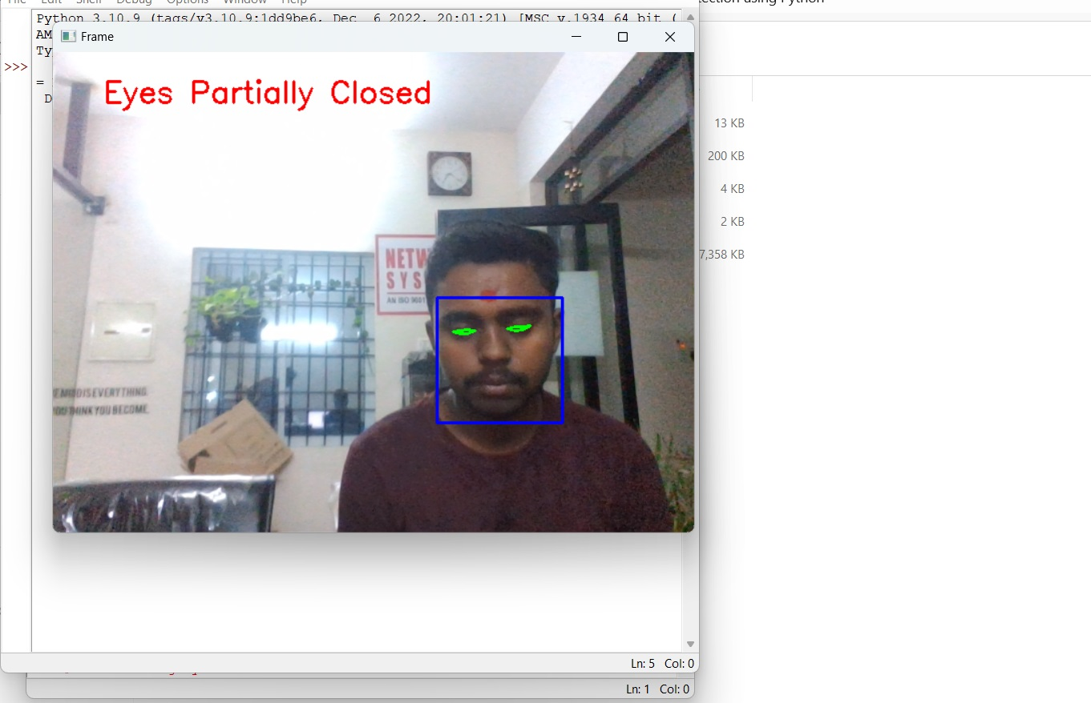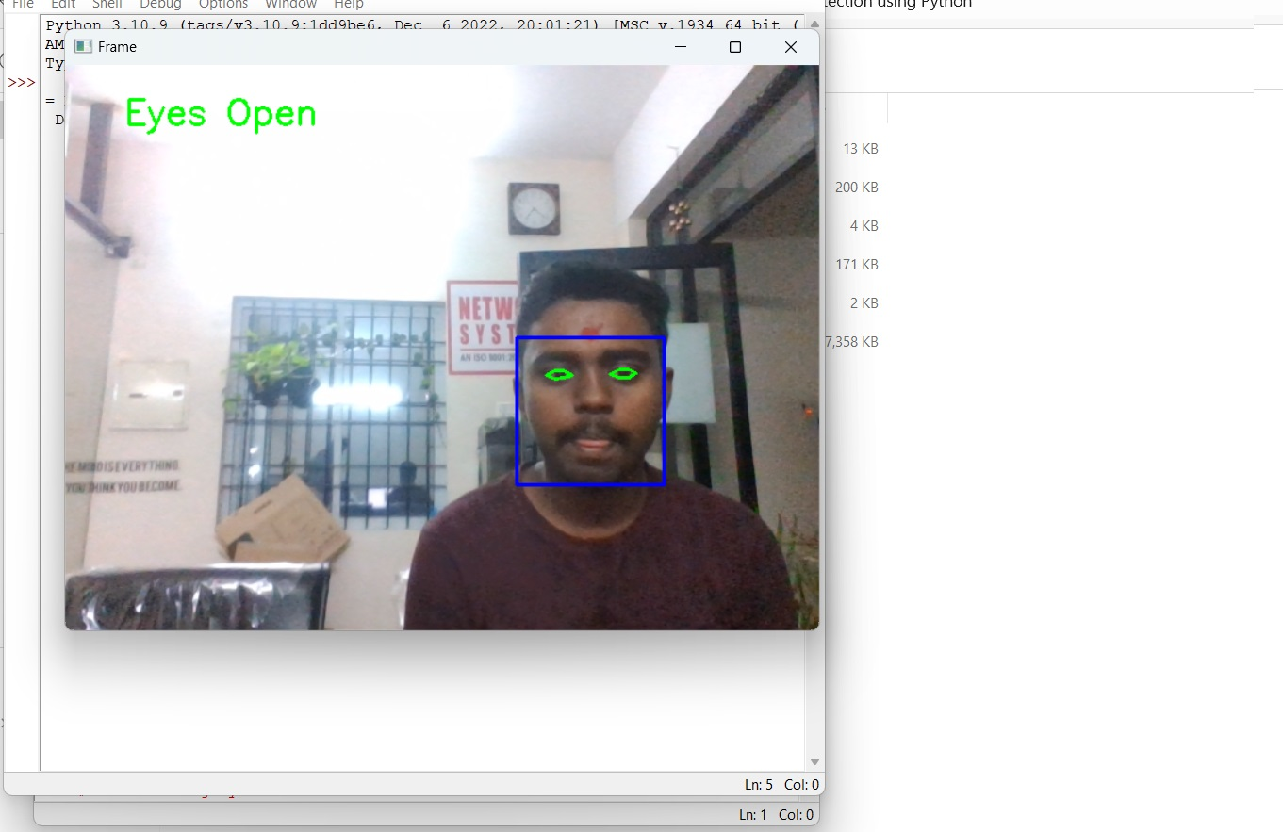

1. **SAMPLE OUTPUT**



